### Upload to NAXT

1. Navigate to GGNZ/Service/Periodic > Upload SMU

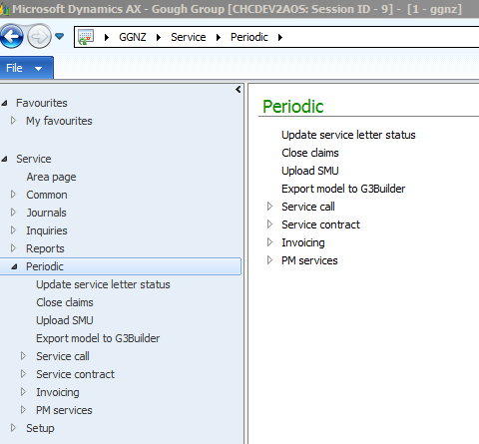

1. From the form that opens,
   * Select the Capture date. Use the date of the file name.
   * Select the File. This is the NAXT Service Vehicle SMU Upload template found in, P:\Roger Capil\OGL\NAXT SMU Upload
   * Select the Code. From the drop down select STD

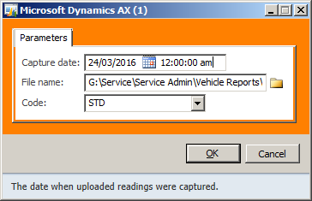

1. Once the detail is entered, select OK
2. Navigate to GGNZ/Service/Journals > SMU upload journal

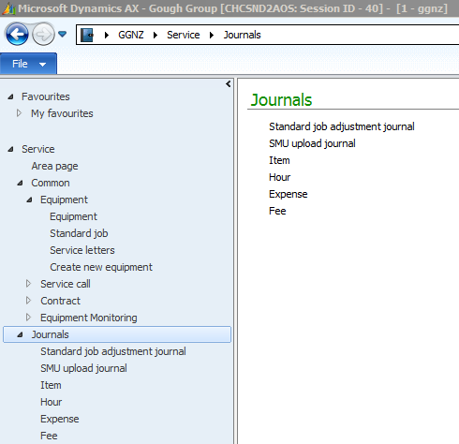

1. From the SMU upload journal, select the ‘To be approved’ check box then F5

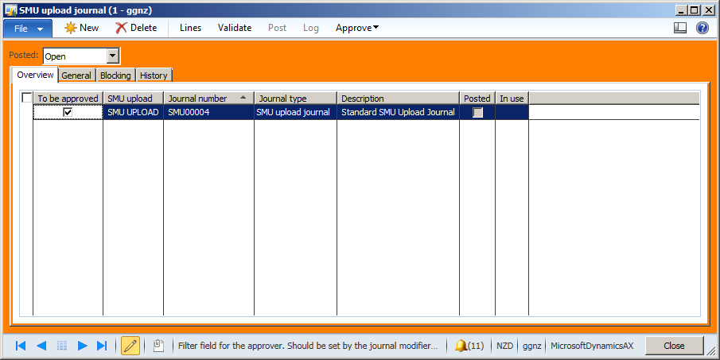

1. From the SMU upload journal, Approve drop down, select Approve

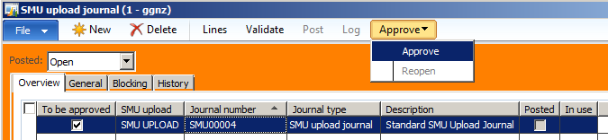

1. From the SMU upload journal, select Post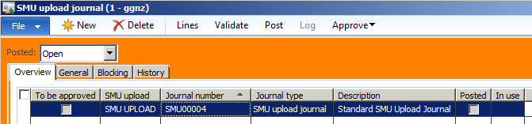
2. SMU will now be updated on the Service vehicles in the Equipment usage history table, GGNZ/Service/Inquiries/Equipment > Usage history and Vehicle efficiency reports can be generated

